Task: 02 Date:26-06-2026

Sub: Merging in Git

What is Merging in Git?
Merging means combining the changes from one branch into another branch.

Step 1: Create a Folder
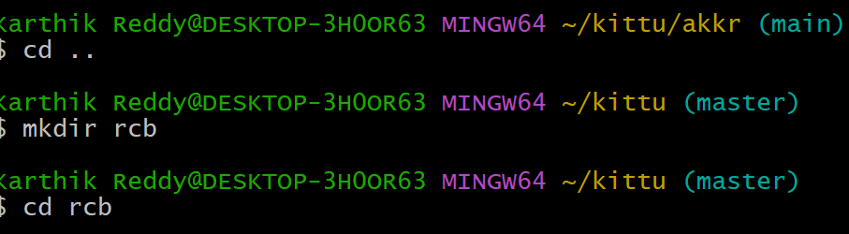

Step 2: Initialize Git and Create an HTML File

Step 3: Write HTML Code and Check Git Status
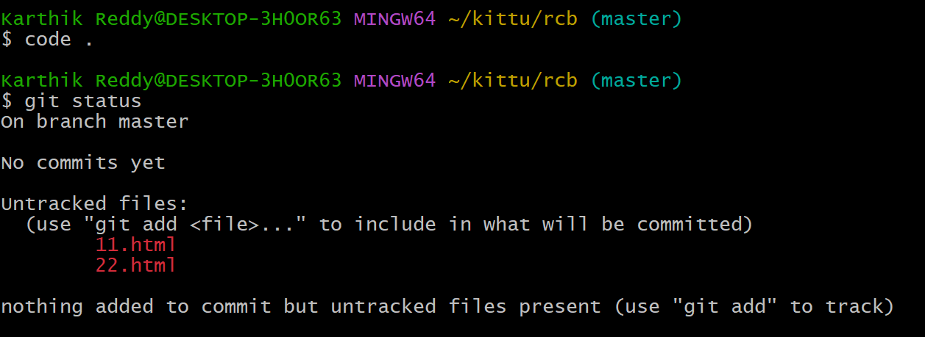

Step4: Add the and commit
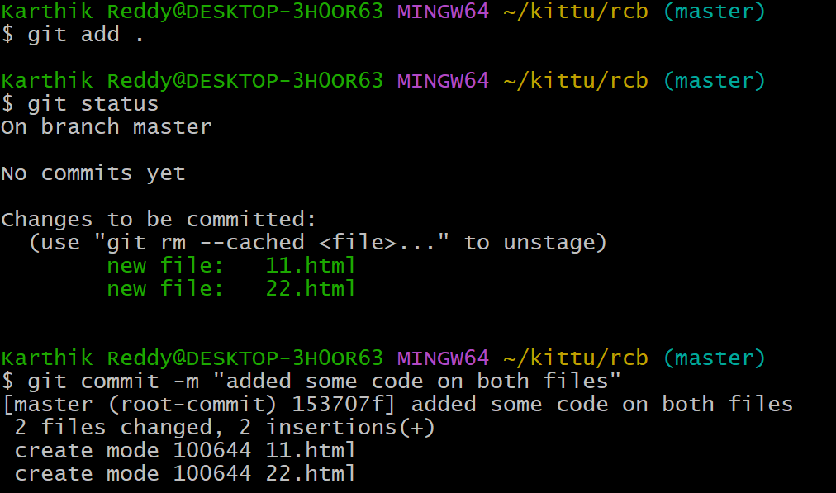

Step5: create the another branch and file commit it
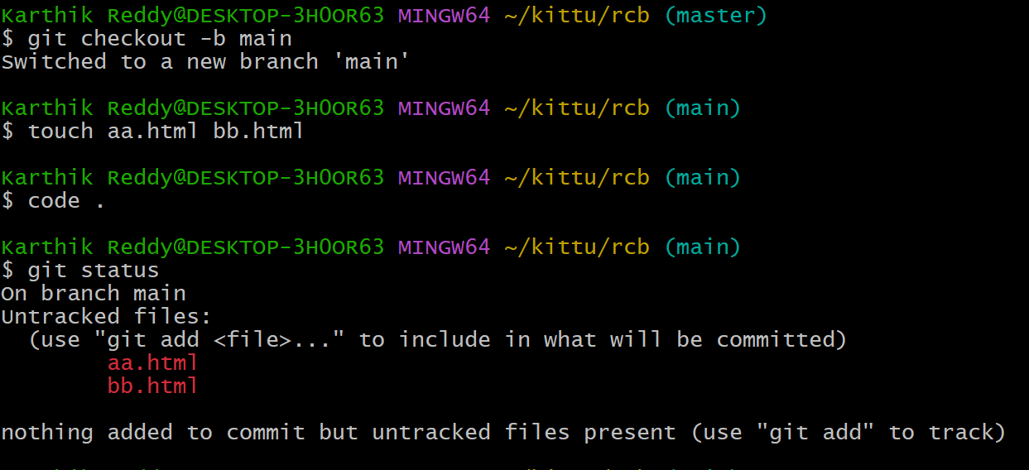

In the branch main and master branch files
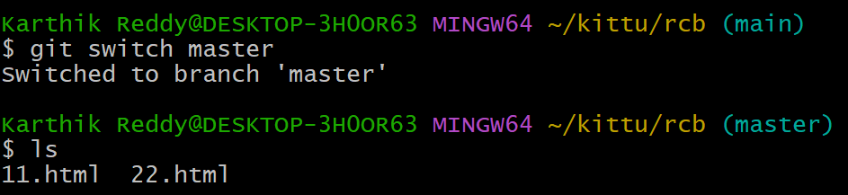

To see the merged once
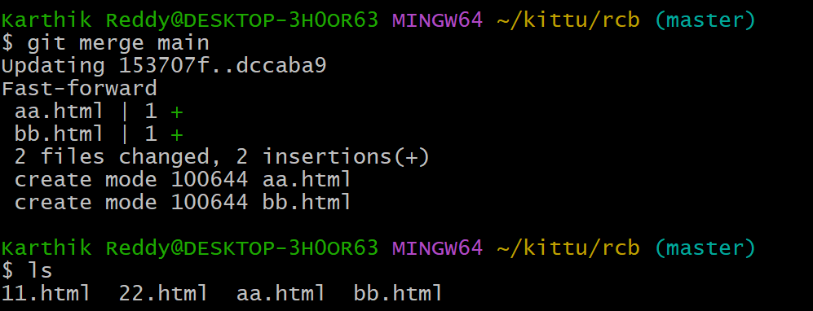

Step6: another branch add and commit
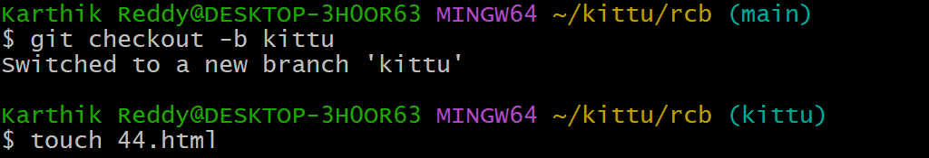
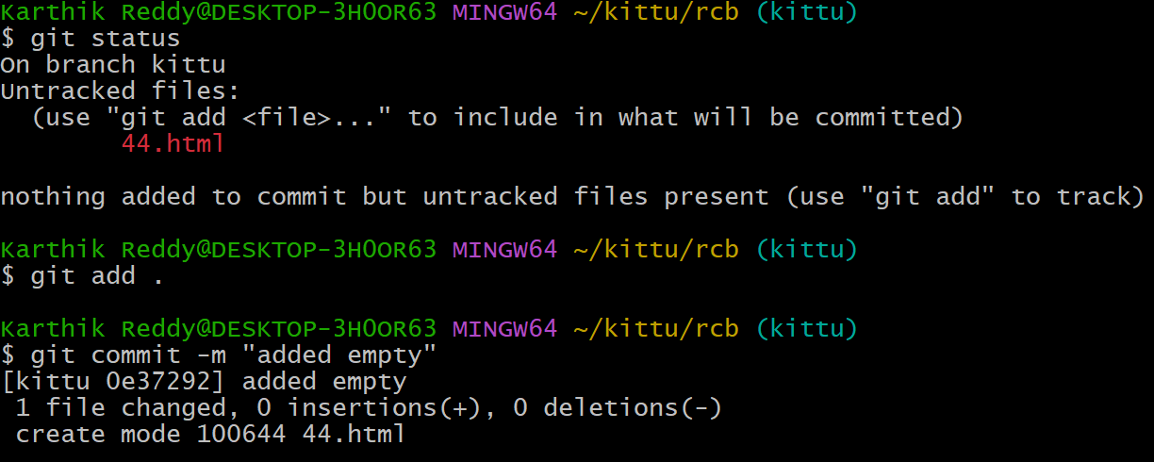

step 7: switch the branch to main and change the code and add and commit it
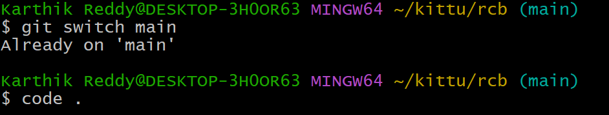
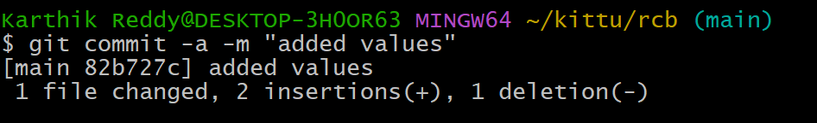

Step8: switch to branch kittu and change the code and add and commit it
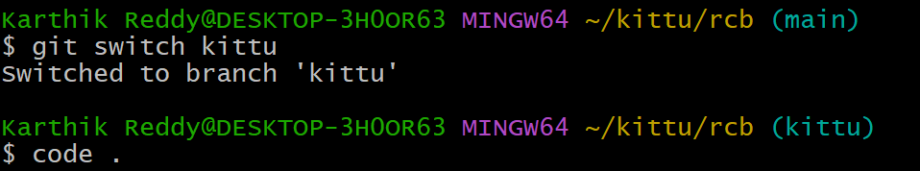
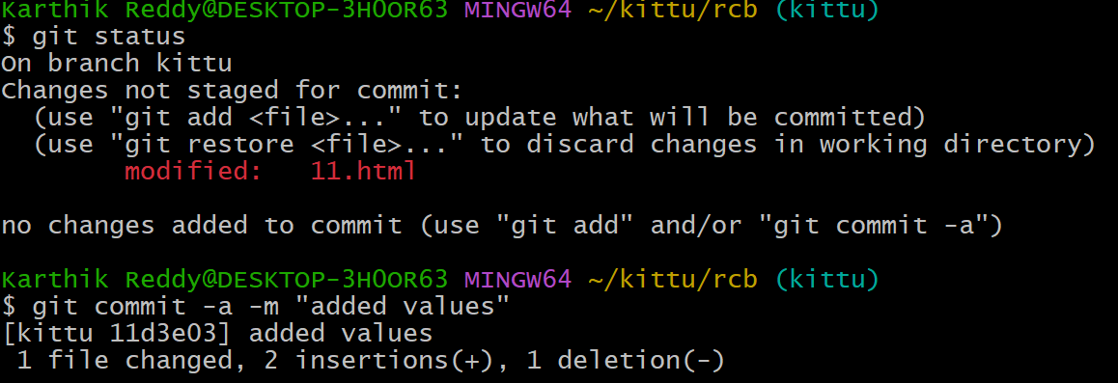

– step 9: To see the conflict
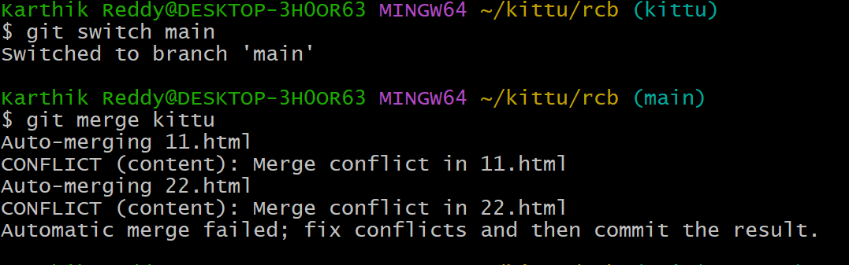

Step10 :To see the what changes in both code
